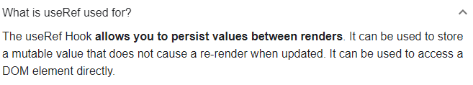

import React, { useEffect, useRef } from 'react';

*// preserves value*

*// DOES NOT trigger re-render*

*// target DOM nodes/elements*

const UseRefBasics = () => {

const refContainer = useRef(null);

const handleSubmit = (e) => {

e.preventDefault();

console.log(refContainer.current.value);

};

useEffect(() => {

console.log(refContainer.current);

refContainer.current.focus();

});

return (

<>

<form className='form' onSubmit={handleSubmit}>

<div>

<input type='text' ref={refContainer} />

</div>

<button type='submit'>submit</button>

</form>

</>

);

};

export default UseRefBasics;



